1. Project Documentation: Heart Failure Analytics Dashboard
I. Project Overview
This project involves the development of a diagnostic and predictive dashboard using a dataset of heart failure clinical records. The primary objective is to visualize patient survival patterns and identify the clinical indicators (e.g., Ejection Fraction, Serum Creatinine) that most heavily influence mortality risk.
II. Dataset Specifications
- Total Records (Rows): 596 rows.
- Total Dimensions (Columns): 13 columns.
- Categorization of Data:
  - Demographics: Age, Sex.
  - Comorbidities (Historical Risks): Anaemia, Diabetes, High Blood Pressure, Smoking.
  - Clinical Vital Signs & Lab Metrics: Creatinine Phosphokinase, Ejection Fraction, Platelets, Serum Creatinine, Serum Sodium.
  - Tracking & Outcome: Time (Follow-up period), DEATH_EVENT (Target variable).
III. Data Transformation & Modeling
To improve dashboard readability for medical stakeholders, raw binary values were transformed into descriptive labels:
- Sex Mapping: 0 $\rightarrow$ "Female", 1 $\rightarrow$ "Male".
- Lifestyle Mapping: 0 $\rightarrow$ "Non-Smoker", 1 $\rightarrow$ "Smoker".
- Clinical Condition Mapping: 0 $\rightarrow$ "Non-Anaemic / Normal", 1 $\rightarrow$ "Anaemic / High".
- Age Segmentation: Created a calculated column Age_Group using the logic:
  - Youth: < 40 years.
  - Middle Aged: 40 to 60 years.
  - Senior: > 60 years.
IV. Visual Logic & Dashboard Breakdown
Based on the final dashboard layout, here is the functional logic applied:
- KPI Executive Strip: Displays Total Survival, Total Deaths, and Death Rate (as a percentage) to provide an immediate situation report.
- Survival & Death by Age Group: A clustered bar chart that visualizes volume distribution. It clearly identifies "Seniors" as the highest volume risk group.
- Average Heart Pump Efficiency (Gauge): Monitors Ejection Fraction. The gauge is set with a target at 50%, immediately flagging when a filtered group falls into the "Critical Heart Failure" zone (sub-40%).
- Mortality Rate Heatmap: A matrix crossing Smoking vs. High Blood Pressure. Conditional formatting (Crimson Gradient) is used to highlight the 44-45% mortality spike in smoking patients with hypertension.
- Clinical Risk Correlation (Scatter): Correlates Serum Creatinine against Ejection Fraction to identify a "Risk Zone" where high creatinine levels and low heart efficiency meet
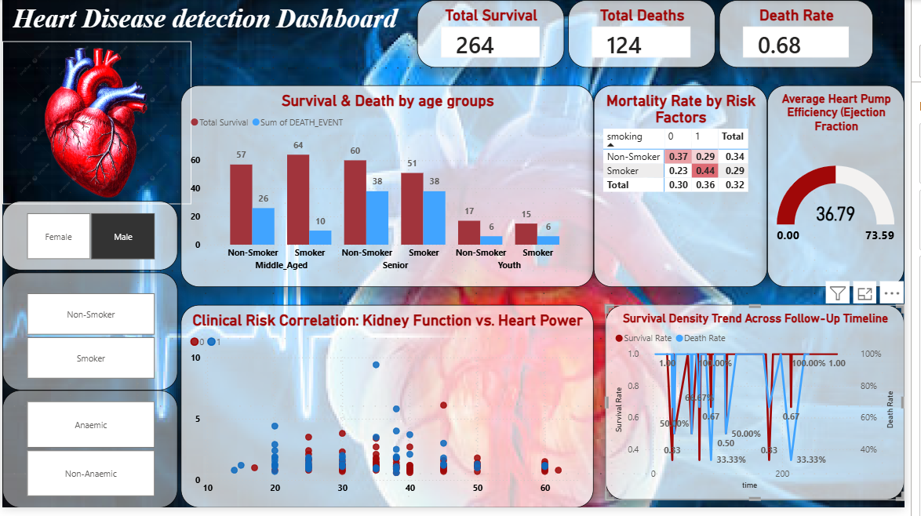

Slected for Female
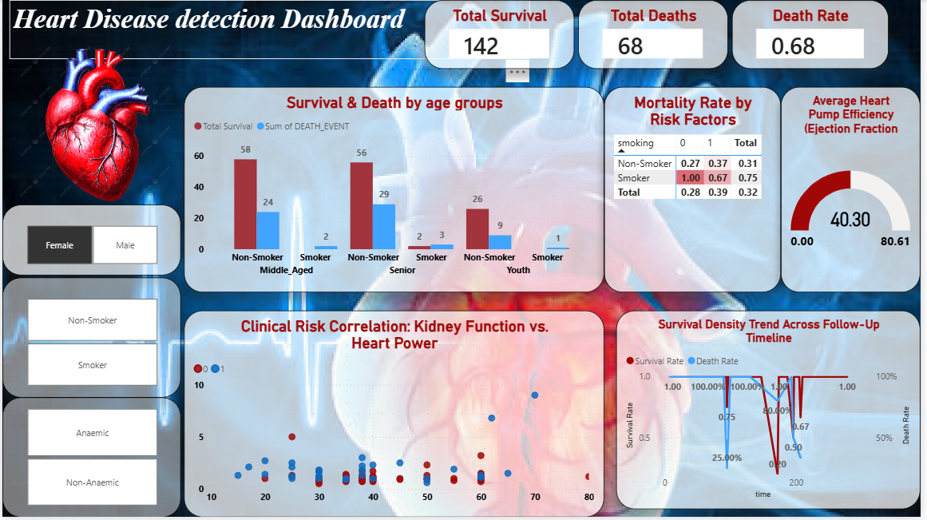
PPT presentation to AVP.

